

Foundations of Programming

Assignment No.: 18
PROBLEM STATEMENT: Write a C program that accepts a string from the user and performs the following string operations: i) Calculate length of string ii) String reversal iii) Equality check of two strings iv) Check palindrome v) Check substring.

OBJECTIVE:

- To understand basic string operations in C.
- To learn how to manipulate strings using loops and functions.
- To perform comparison, reversal, and substring checking.
- To check whether a string is a palindrome.

THEORY:
In C programming, a string is a sequence of characters terminated by a null character ('\0'). Strings are commonly stored in character arrays. Various operations can be performed on strings such as calculating their length, reversing the characters, comparing two strings, checking whether a string is a palindrome, and finding a substring within another string. These operations can be implemented using loops and conditional statements or by using standard library functions from the string.h header file.
PLATFORM: Linux

ALGORITHM:
Step 1: Start
Step 2: Declare variables: char s1[ ], s2[ ], s1copy[ ]
Step 3: Input first string s1
Step 4: Input second string s2
Step 5: Find length of string: len = strlen(s1)
Step 6: Copy string: strcpy(s1copy, s1)
Step 7: Reverse string:
For i = 0 to len/2
temp = s1copy[i]
s1copy[i] = s1copy[len-i-1]
s1copy[len-i-1] = temp
Step 8: Display reversed string
Step 9: Check palindrome
If strcmp(s1copy, s1) == 0
Print "Palindrome"
Else
Print "Not Palindrome"
Step 10: Check equality
If strcmp(s1, s2) == 0
Print "Strings are equal"
Else
Print "Strings are not equal"
Step 11: Check substring
If strstr(s1, s2) != NULL
Print "Substring found"
Else
Print "Substring not found"
Step 12: Stop

FLOWCHART:
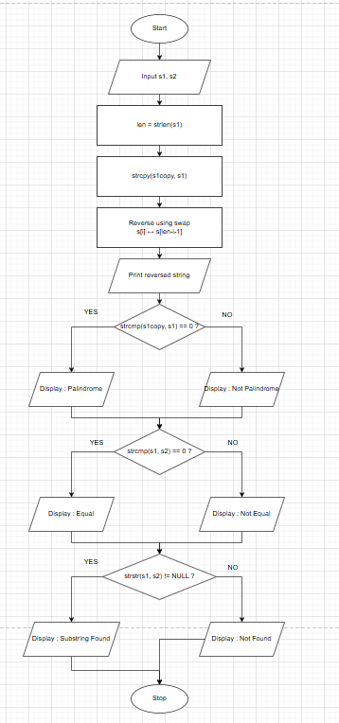

CODE:
#include <stdio.h>
#include <string.h>

int main() {

char s1[10],s2[10];

printf("Enter a string : ");
scanf("%s",&s1);

printf("Enter another string for equality check : ");
scanf("%s",&s2);

printf("\n");
int len=strlen(s1);
printf("Length of string = %d\n",len);

char s1copy[10];
strcpy(s1copy,s1);
for(int i=0;i<(len/2);i++){
char c=s1copy[i];
s1copy[i]=s1copy[len-1-i];
s1copy[len-i-1]=c;

}

printf("Reversed string : %s\n",s1copy);

if(strcmp(s1copy,s1)){
printf("The string is a Palindrome\n");
}
else {
printf("The string is a Palindrome\n");
}

if(strcmp(s2,s1)==0){
printf("Strings are equal\n");
}
else {
printf("Strings are not equal\n");
}

if(strstr(s1,s2)){
printf("Substring found in main string\n");
}
else {
printf("Substring found in main string\n");
}

return 0;
}

INPUT: A string and another string for comparison and substring checking.
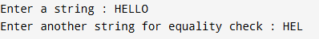

OUTPUT: Displays string length, reversed string, equality result, palindrome result, and substring check result.
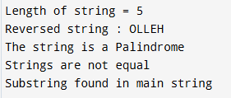

SAMPLE INPUT:

Enter a string: madam
Enter another string for equality check: mad
SAMPLE OUTPUT:
Length of string = 5
Reversed string = madam
The string is a Palindrome
Strings are not equal
Substring found in main string

CONCLUSION: Thus, the C program successfully performs different string operations such as length calculation, reversal, equality check, palindrome check, and substring detection.

FAQs:
- What is a string in C programming?
- Which header file is required for string functions?
- What function is used to find the length of a string?
- What is a palindrome string?
- Which function is used to check a substring in C?

